**Report 10: Image representation and description**

**Ge Yunhao （116020910017）**

**[Problem 10]**

(a). Develop a program to implement the boundary following algorithm, the resampling grid and calculate the chain code and the first difference chain code. Use the image ‘noisy_stroke.tif’ for test. (For technique details, please refer to pp.818-822 (3rd edition, Gonzalez DIP) or boundaryfollowing.pdf at the same

address of the slides.)

(b). Develop a program to implement the image description by the principal components (PC). Calculate and display the PC images and the reconstructed images from 2 PCs. Use the six images in ‘washingtonDC.rar’ as the test images. [Solve]

**Program:**

Main: Project10.m.

Function : fun_getNextPoint.m; fun_getStartPoint,m

**Input:**

(1) origin\ noisy_stroke.tif.

(2) origin\ WashingtonDC_Band1.tif.

origin\ WashingtonDC_Band2.tif.

origin\ WashingtonDC_Band3.tif.

origin\ WashingtonDC_Band4.tif.

origin\ WashingtonDC_Band5.tif.

origin\ WashingtonDC_Band6.tif.

**Output:**

(1) Figure 10.1original somthed image, boundary,Big-grid and Grid image.jpg.

(2) Figure 10.2 reconstruct1.jpg.

(3) Figure 10.3 reconstruct2.jpg.

(4) Figure 10.4 reconstruct3.jpg.

(5) Figure 10.5 reconstruct4.jpg.

(6) Figure 10.6 reconstruct5.jpg.

(7) Figure 10.7 reconstruct6.jpg.

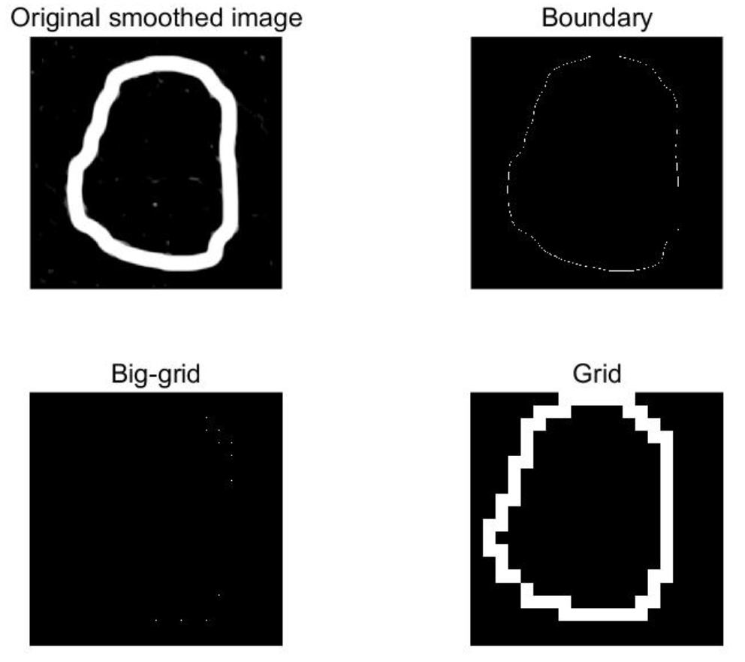

Figure 10.1 original somthed image, boundary,Big-grid and Grid image

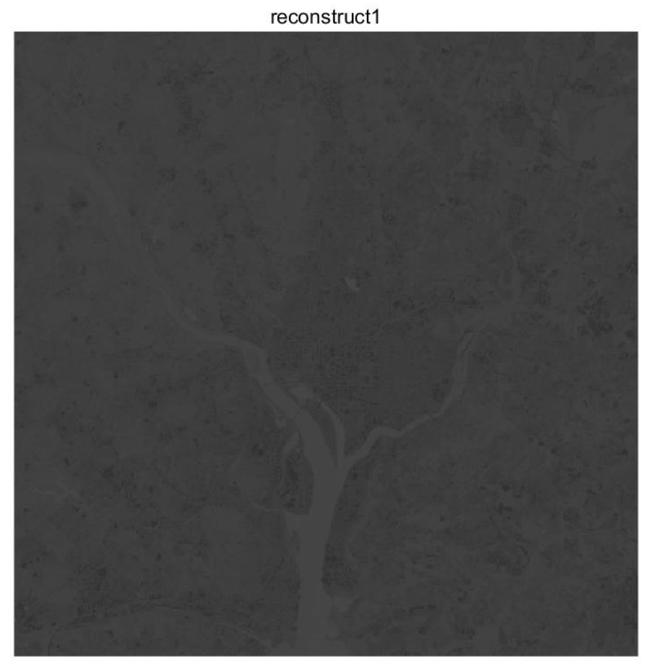

Figure 10.2 reconstruct1.jpg.

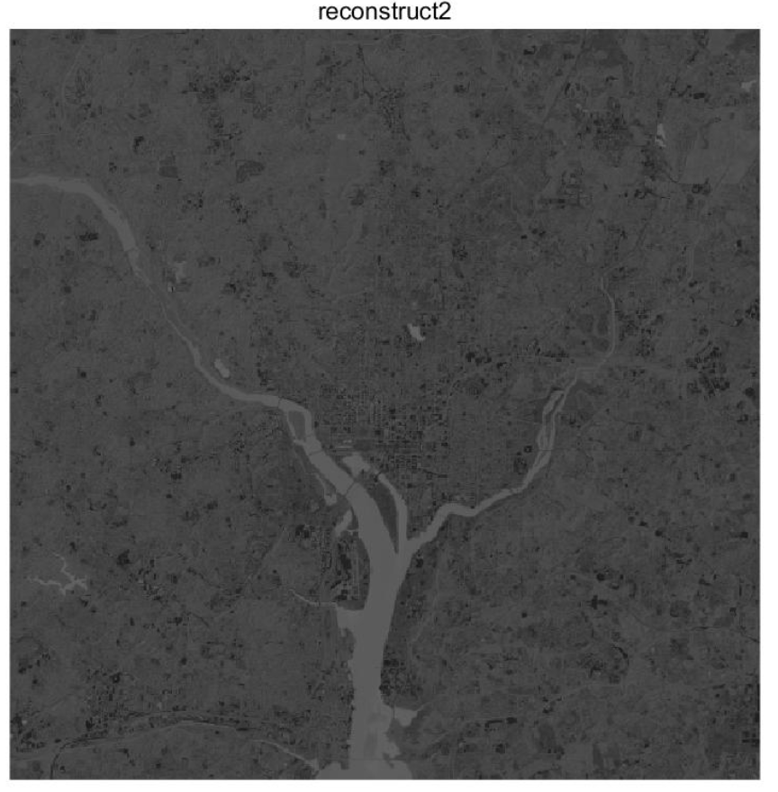

Figure 10.3 reconstruct2.jpg.

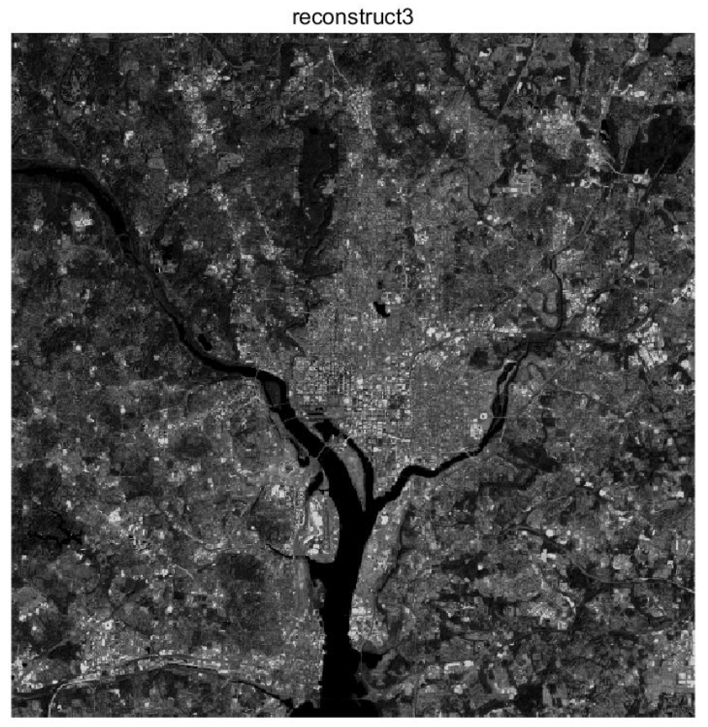

Figure 10.4 reconstruct3.jpg.

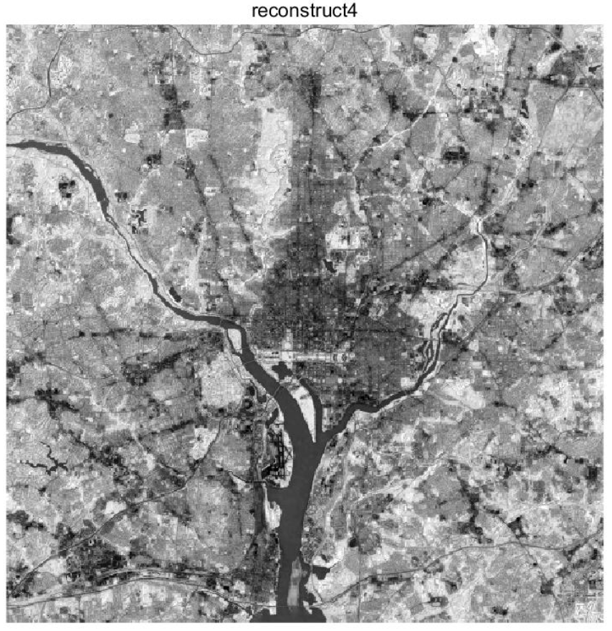

Figure 10.5 reconstruct4.jpg.

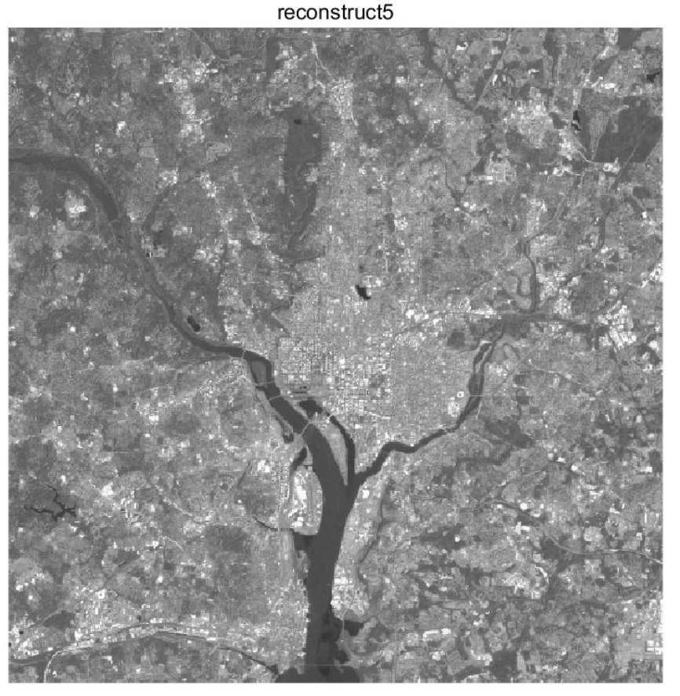

Figure 10.6 reconstruct5.jpg.

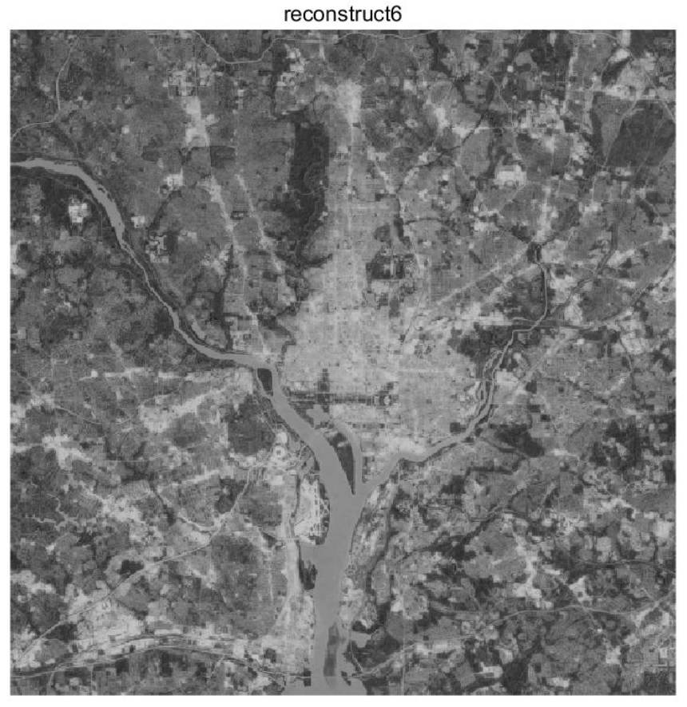

Figure 10.7 reconstruct6.jpg.